**Menoufia University**

**Faculty of Electronic Engineering**

**Embedded Systems (Lab.)**

**(servo motor)**

**DEPARTMENT:**

* **Department of Engineering and Computer Science, 4rd year**

**STUDENT NAME:**

* **امجد مجدي فتحي سيد احمد**
* **سكشن (1)**
* **مجموعه (8)**

**Task #4 (LM35):**

**We are going to have a servo motor connected with Arduino and the Arduino will read the analog value coming from the potentiometer and the servo movement is controlled by changing the potentiometer value. Display the results using serial communication.**

**Required components for this lab:**

* **Breadboard**
* **Wires (male - male)**
* **1 potentiometer (5KΩ or 10KΩ).**
* **1 servo motor.**

**Circuit diagram:**

**Code:**

#include "Servo.h"

#define pot  A0

#define servo  12

Servo servoMotor;

int potReading = 0 ;

void setup() {

**Serial**.begin(9600);

  pinMode(pot, INPUT);

  servoMotor.attach(servo);

}

void loop() {

  int potReading = analogRead(pot);

  float servoValue = potReading * (180 / 1023.0);

  servoMotor.write(servoValue);

**Serial**.print("Analog Reading: ");

**Serial**.print(potReading);

**Serial**.print(", Degree Of Servo: ");

**Serial**.println(servoValue);

  delay(100);

}

**Simulation:**

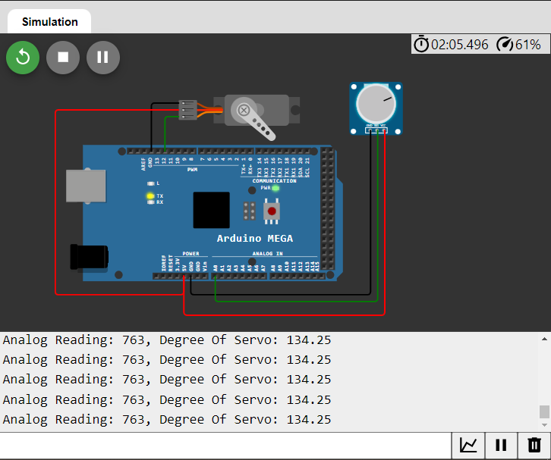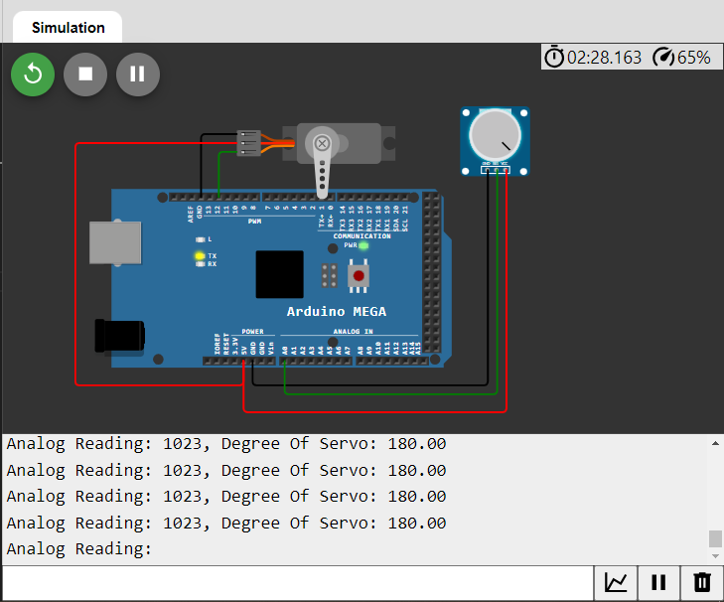

**My Simulation to run code:**

[**https://wokwi.com/projects/396003103905647617**](https://wokwi.com/projects/396003103905647617)

**Or Scan QR Code:**